JOLINNE KEARNS, MPR
Director, Marketing and Communications, (she/her)
5163 Duke Street
K'jipuktuk/Halifax, NS B3J 3J6
902-494-8251 / 647-269-6961 / jkearns@nscad.ca
nscad.ca / @NSCADUniversity
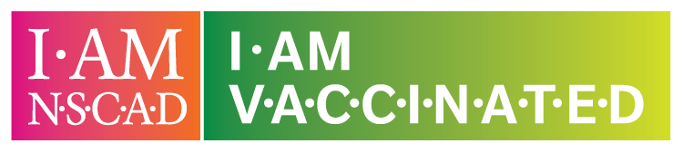
NSCAD University will be hosting a walk-in COVID -19 vaccine clinic on September 10, 2021, from 10 a.m. – 3 p.m. at the Art Bar +Projects (1875 Granville Street).

NSCAD University is in Mi’kma’ki, on the ancestral and unceded territory of the Mi’kmaq Nation.
This email message (including attachments, if any) is confidential and may be privileged. Any unauthorized distribution or disclosure is prohibited. Disclosure to anyone other than the intended recipient does not constitute a waiver of privilege. If you have received this email in error, please notify me and delete it and any attachments from your computer system and records.

Alt Text:
Reminder – add ALT text to your signature photo! When you’ve opened Signatures and you are adding the new graphic, make sure you right click on the image and choose “Picture…”
Paste the following copy in the Alt Text box:
Graphic: Two boxes, one which reads I AM NSCAD in a pink box, and I AM VACCINATED in a green box.
