Accommodate Faculty User Instructions
NSCAD
NSCAD has implemented a new accommodation letter management platform called Accommodate. Your Accommodate portal will house important information about your students’ accommodations. Please follow the step-by-step instructions below to access and navigate your Accommodate portal.

Log-in to Accommodate here: https://nscad-accommodate.symplicity.com and select “Faculty”

After you log-in you will arrive in the “Home” section.

To view a student’s accommodation letter select “Accommodation Letters.” Select the letter that you wish to view. Your signature is requested, “Requested” will appear in a black rectangle next to the letter. Once a letter is signed, the text will indicate “signed.”

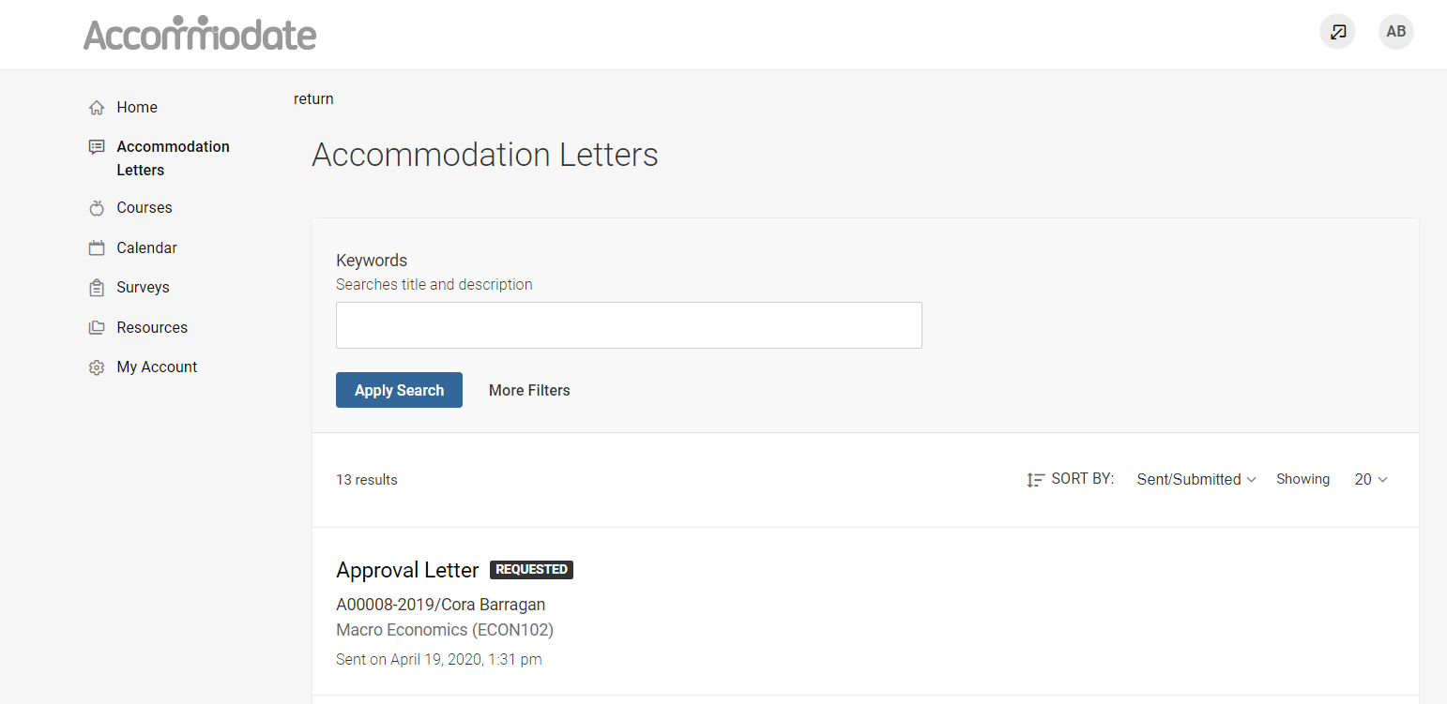

Once the letter is open, you have the option to print or generate a PDF of the accommodation letter. Your signature is requested, please complete the form as indicated. To return to the full list, select “Return to List (Accommodation Letter)”. You will no longer meet with students in person to discuss accommodation letter. Both parties will sign independently. If you have questions or clarifications about an accommodation you can email the accessibility advisor or the student directly.

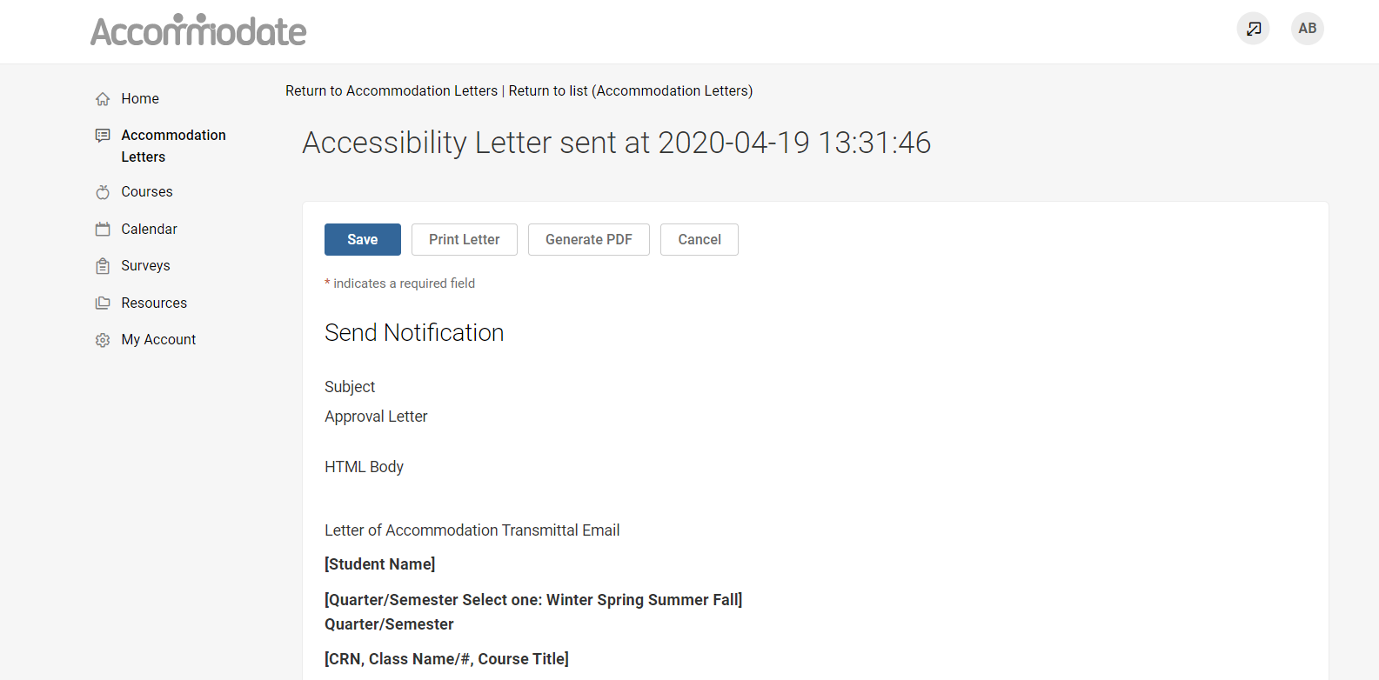

To view a list of students enrolled in your course with accommodations, select “Courses.” Select the course you wish to view. Here you can view enrolled students and exams.

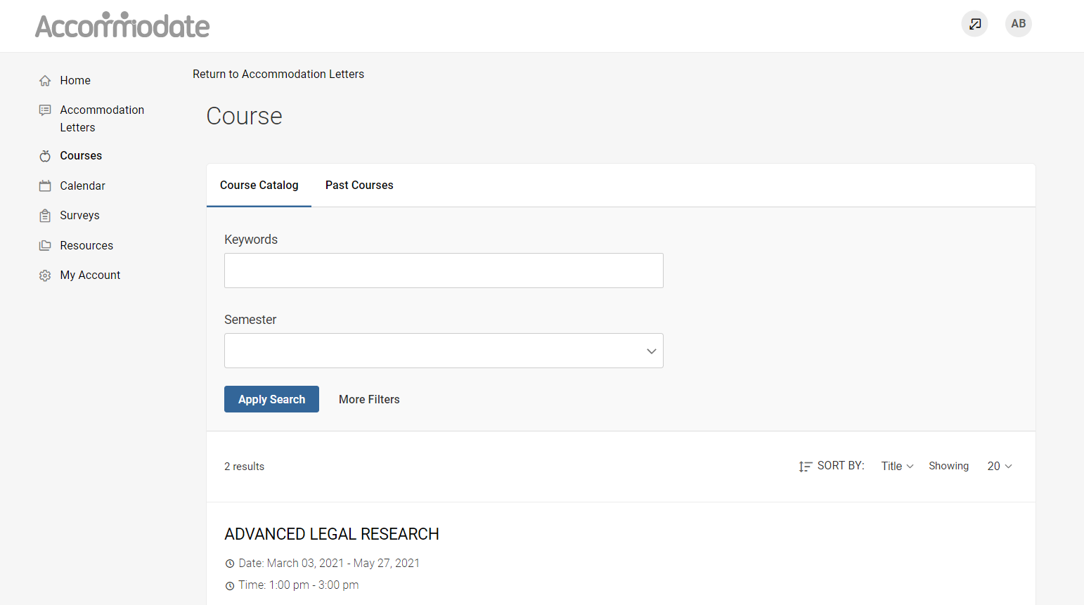

To view enrolled students with accommodations, select “Enrolled Students” and then select “More Filters.” Select “Yes” Under Approved Accommodations for this Course to view only students who are approved for accommodations in this course.

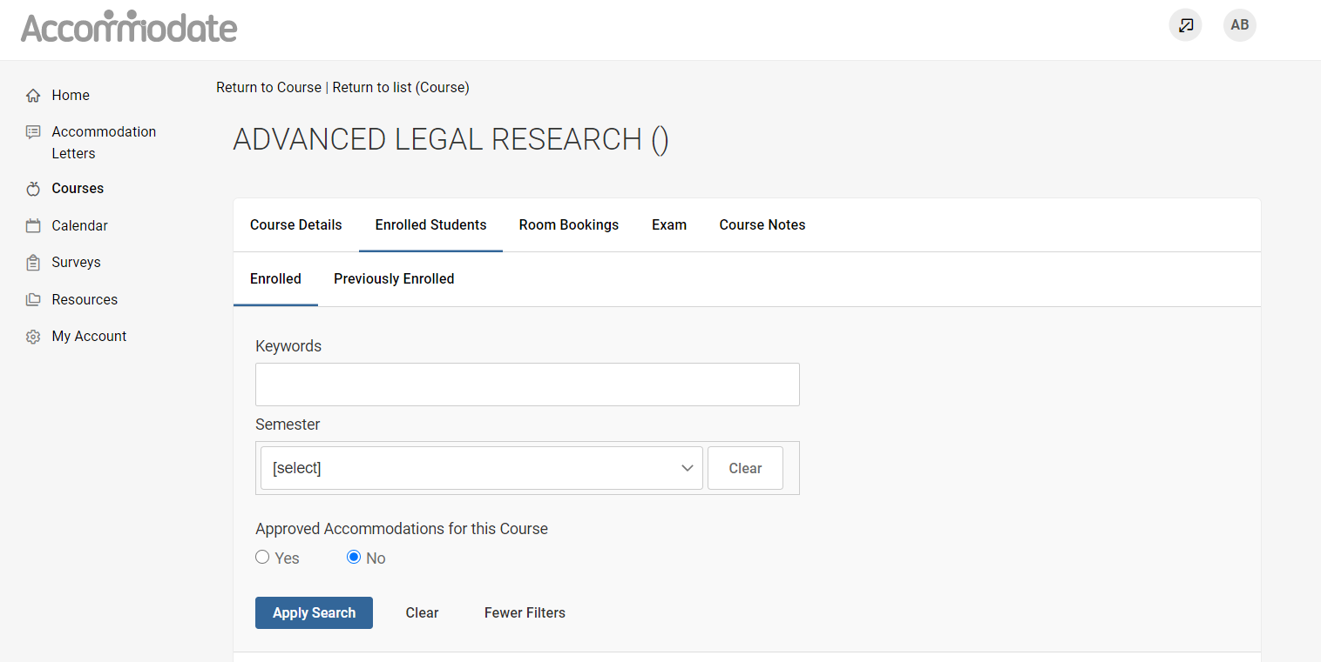

To view resources uploaded by Accessibility Office, select “Resources” > “Resource Library”

By selecting “Personal Profile” on the homepage you can view and edit your account details
